**Module 6– Final Project Report**

Name: Mr. Pradeep Ginjupalli, Ms. Rohini Desai, Mr. John DiSessa

Date: 10/27/2021

Title: Module 6- Final Project Report

Course: ALY6015 (Intermediate Analytics)

Term: Fall 2021

Exploratory Data analysis of Airbnb Boston dataset

We will be using multiple models (Logistic regression, GLM and regularization) to predict rental prices based on listing dataset as it has the best attributes to determine the prices.

Descriptive characteristics of the data set: AirBnb Boston dataset.

The information was derived from a data collection that included 3585 observations and 95 variables.

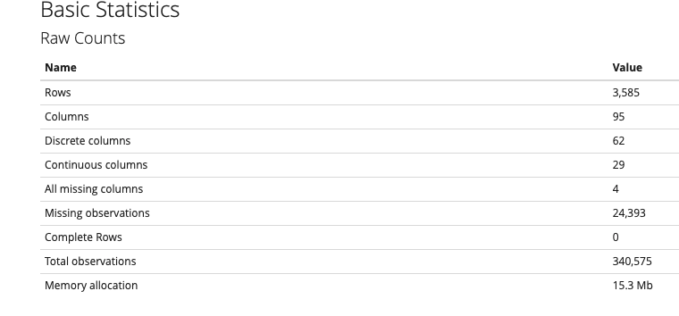

Let's look at the Attributes statistics to have a better understanding of the data structure. The data was ideal for fitting a regression line to determine whether the prices for rooms were ideal or not which was the nicest thing I observed. There is hardly missing data (7%), therefore null values need not be updated, and 30.5 percent of the columns are continuous, and 65.3 percent are discrete, thus it's great for analysis.

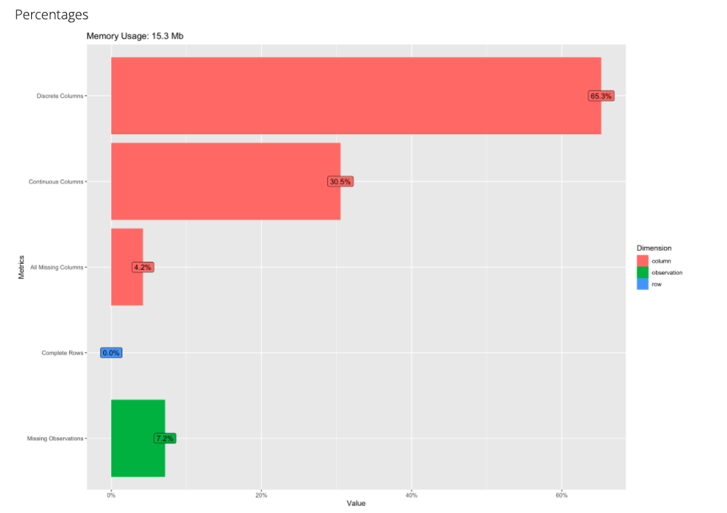

When the data is significantly skewed and so not-normally distributed, we treat it as such. To find those factors, we employ a p-value. The Null Hypothesis concerning not-skewed data is rejected since the p-value for characteristics accommodates, bathroom, review scores rating is minimum, meaning that data for those attributes are significantly skewed. Latitude, longitude and other p-values, on the other hand, are more than the standard significance level of 0.05, suggesting that the data is not skewed and so normal.

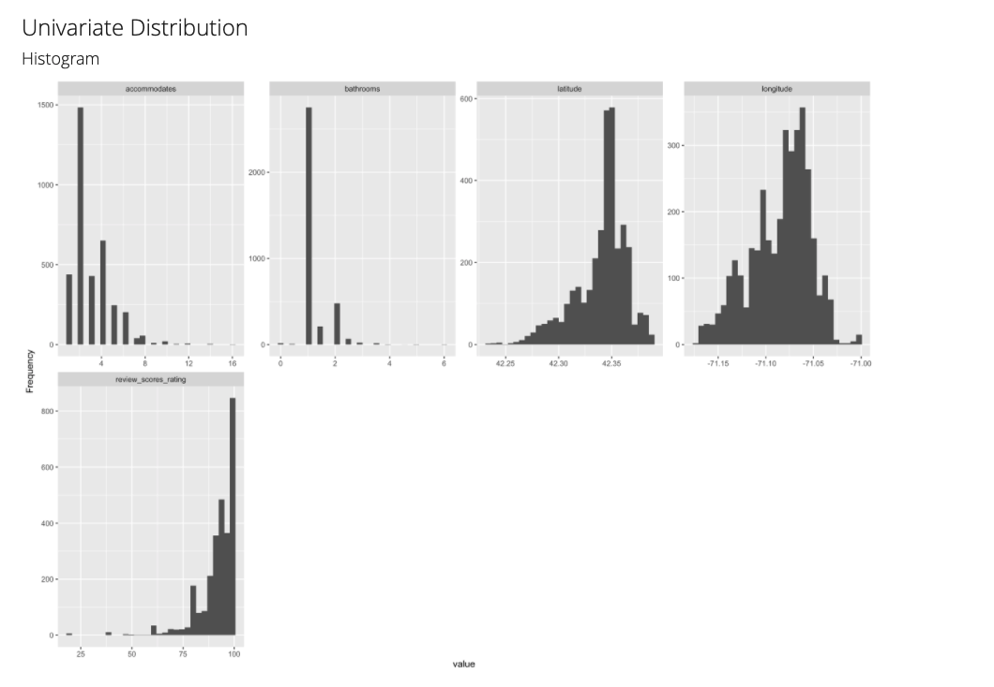

For latitude and longitude bathrooms, the data is mostly symmetrical, although there is some bimodality, as demonstrated by a minor hump near the right tail of the distribution.

One of the most important factors in the data set for me was latitude and longitude. It's only logical to wonder if the latitude and longitude distributions are constant throughout the data structure. According to the above bar chart, there is at least a 60% increase in impact based on latitude and longitude.

To understand the specific dynamics of the dataset, we are considering only few attributes of interest that mostly impact the prices of the listings. We exclude null values for clean data and change the type of price attribute to fit the box plot accordingly.

In our box plots that we have come up to understand the data distribution of rating and prices vs exact location to understand the pricing trend, we do see that at least 75% percentile of prices are location specific and max reviews (75%) are against location specific too. This tells that both price and ratings are directly proportion to location specific.

Also, scatterplot do shows us the similar information. Data is noisier in the higher 75% area and denser.

In correlation plots, the objective of this phase is to show the link between variables. The stronger the connection, the brighter the color and the larger the size. The outcome is similar to the prior one. The graph shows that the price is heavily dependent on modates and location.

The correlation graphic in pie style below depicts the concentration/weightage of the specific variables in the team victory derivation.

**GLM Model**

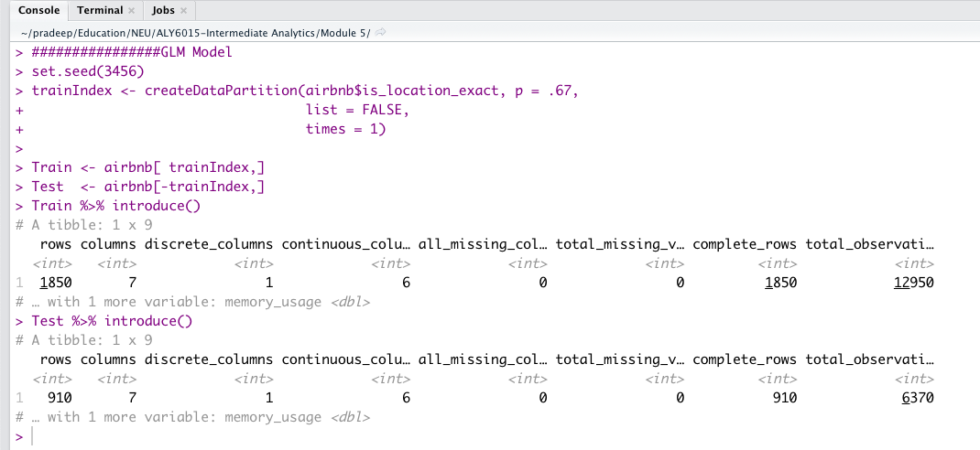Here in this model, we split the given data into test-train segments, then choose a method and a collection of potential models (specify possible tuning parameters for method). After that, we use resampling to determine the "best model" by adjusting the tuning parameters and selecting a model to make predictions using. On the basis of the test data, calculate necessary metrics.

The p-values for the regression coefficients reveal that all attributes except price, longitude and latitude may not make a significant contribution to the equation, and you may not reject the hypothesis. We can probably fit a second equation without them and check if it matches the data as well as the first.

Each regression coefficient is statistically significant in the simplified model (p.05). Because the two models are nested (i.e. logit2 is a subset of logit1), the anova() function can be used to compare them.

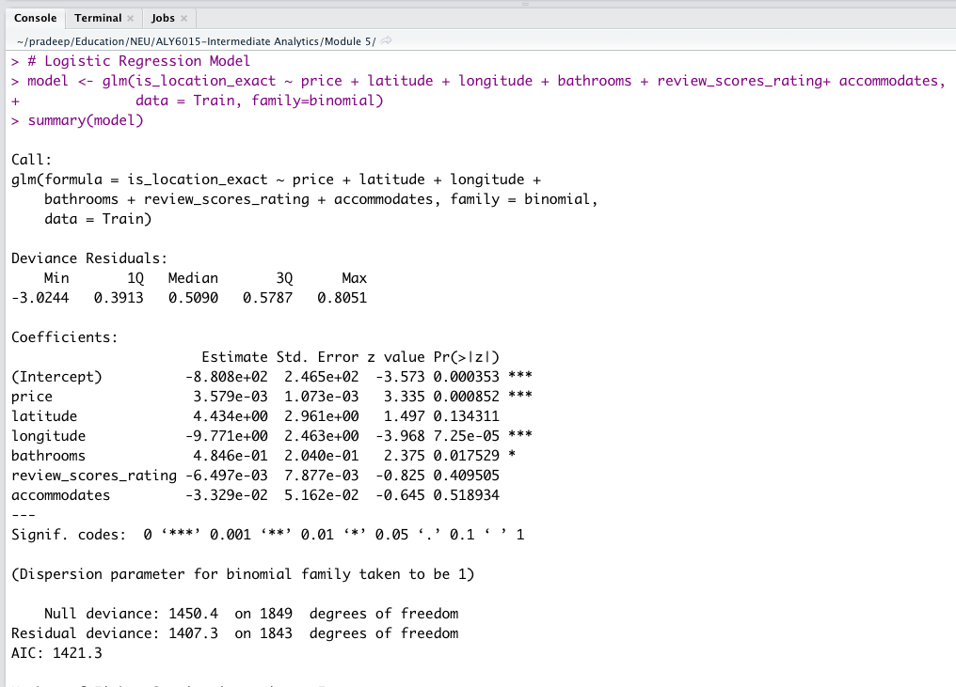

Let's look at regression coefficient first before framing a confusion matrix. We know that in a logistic regression, the response being modeled is the log that Y = 1. When all other predictor variables are held constant, the coefficients of regression accurately indicate the change in log(odds) in the response for a unit change in the predictor variable. Because log(odds) is usually difficult to read, it can be exponentiated to make an odds scale. Now we can see that for every rise in outstate, the probability of a price incurring increasing by a factor of 1.003. With each % shift in price, however, the chances of having one increase by a factor of 3.57.

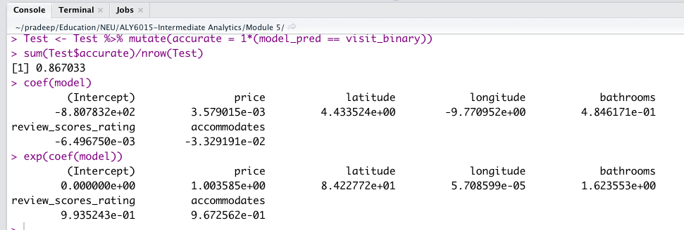

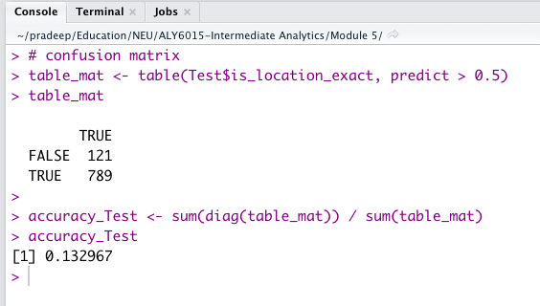

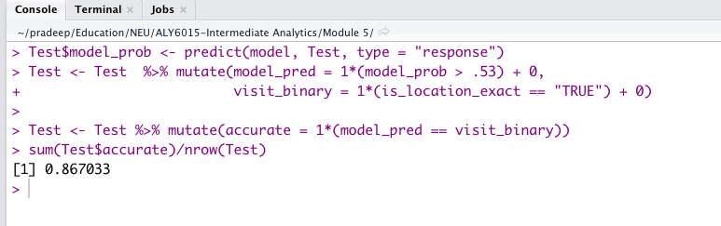

When pricing is linear with accommodation, bathrooms, longitude, and latitude, we get the odds that it is 86.7 percent accurate to tell. The model's ability to predict the target variables is now the most significant statistic when developing prediction models.

True positive is 789 and True Negative is 121, as shown in the screenshot above. We can see that our false positive rate isn't very high, and that our false negative rate is also lower than our true positive rate. In terms of projecting model accuracy, we obtained 86.7 percent, which isn't terrible but not great. Also, 13.2% of accuracy indicates that identification of 1 of every 10 listing as over pricing is wrong and 9 are correct.

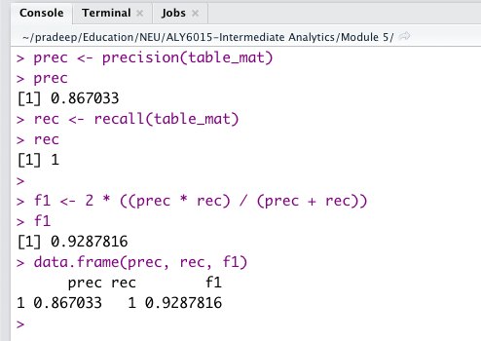

When it predicts that a price is accurate it gets it right around 86 percent of the time, or 0.867.

Precision also allows us to calculate the number of relevant data points. Recall is 1 in our model. Recall is a metric that indicates how well our model can detect relevant data. It's also known as True Positive Rate or Sensitivity. What if a patient suffers heart disease but receives no therapy because our algorithm anticipated that he or she would? That's a predicament we'd rather avoid!

The ROC curve shown above, but with some additional graphical parameters: The threshold color-codes the ROC curve, and selected threshold values are printed on it. In addition, the ROC curve's convex hull (black broken line) is depicted.

The TPR (true positive rate) and FPR(false positive rate) are calculated and plotted at each threshold. The more cutoffs the forecasts have, the smoother the graph is. A 45-degree line was also drawn, which reflects the average performance of a uniform random variable.

The area under the ROC curve seems to be a good way to evaluate and compare overall classification model performance. We can see that our plot is significantly good in the screenshot above, and we can expect our dotted line to run from 0 to the top corner, then to the end, giving us the best prediction model. This curve offers us confidence in our ability to forecast how our model will perform over the stated criteria.

**Regularization**

We then took our model evaluation a step further with Regularization. We added a lambda value to decrease overfitting our model to the dataset and to decrease the variance in our predictors at the expense of increasing bias. We chose to Lasso (L1) Regression since that helps reduce overfitting and also can remove predictors that don’t help the model.

First, we plotted the results of our cross-validation function, where the y axis is the mean-squared error and the x axis log of lambda. The numbers on the top show how many variables we would keep in the model depending on the value of lambda. The two dotted lines represent our minimum lambda value and our maximum lambda value within 1 standard error. Our minimum lambda value is 1.9 and our maximum lambda value within 1 standard error is 4.4.

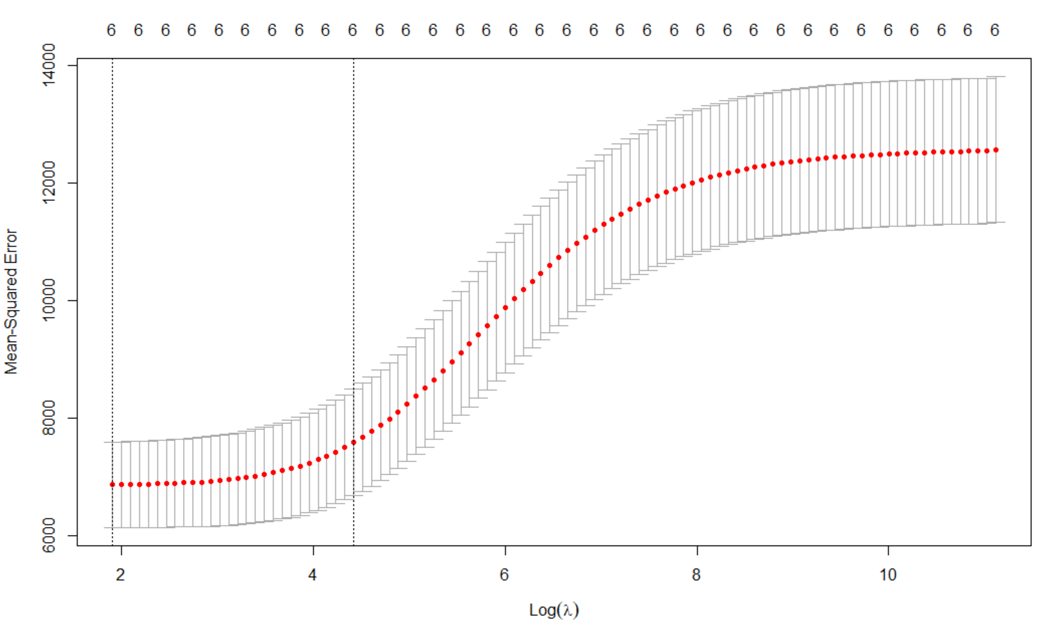

Since both lambda values have us keep 6 variables, we have to see how each model adjusts the coefficients of each variable. The lambda 1se value reduces our coefficients more than the minimum lambda value, but neither model removes any variables entirely.

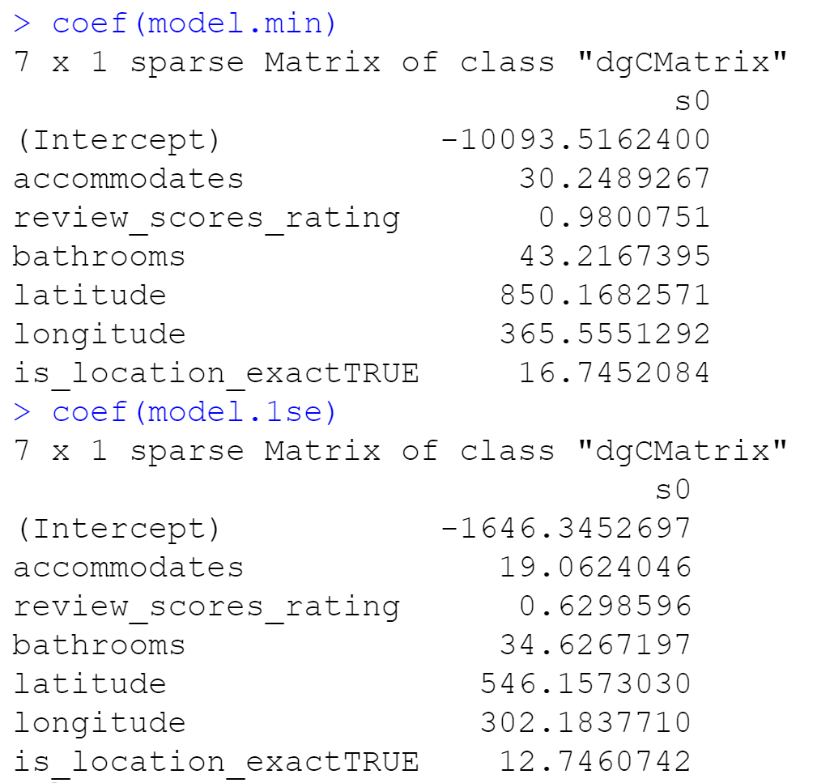

Lastly, in order to determine which model to choose, we calculated the RMSE (root mean square error) to see which model has the least. Even though the values are similar, the model using the lambda 1se value had a lower RMSE of 82.3. The RMSE of the model with the minimum lambda value was 86.8.

**Conclusion**

Our exploratory data analysis gave us a great summary of the kind of rental properties and sales we having in our Airbnb dataset. We only focused on the primary attributes that customers value Airbnb properties on, such as location specific data, review score, amenities, and accommodations since these are the most important factors, we felt, were used to determine price.

We then created a generalized linear model to predict prices. If prices are linear, our model was accurate about 87% of the time. However, we then used Lasso Regression to see if our model was overfitting the dataset. We calculated the best lambda value in order to adjust our variable’s coefficients and thus, improved our model.

If we were to continue our analysis outside of this assignment, we would further explore the Airbnb dataset. From Kaggle, our dataset had three files. We looked at the “Listings” file but there were “Reviews” and “Calendar” files with more data on those specific categories. We would analyze those other two files and the variables within them. We could use non-parametric tests to really analyze any type of variables and not be limited to variables we know the distributions of. We could create more models to predict other variables besides Price.

Appendix

###########################################################################

###########################################################################

### AUTHOR: Pradeep Ginjupalli; Rohini Desai; John DiSessa ###

### TOPIC: ALY6010: M4-Final Project: Initial Analysis Report ###

### DATE: 24-Oct-2021 ###

###########################################################################

###########################################################################

# Load libraries

library(tidyverse)

library(gridExtra)

library(ggplot2)

library(leaflet)

library(dplyr)

library(ggthemes)

library(caret)

options(scipen = 999)

# Load data

airbnb_listings <- read_csv("listings.csv")

# Select desired columns from listings only as it has significant information require to predict prices

airbnb <- airbnb_listings %>% select(accommodates, review_scores_rating,

bathrooms, price,latitude,longitude,is_location_exact)

str(airbnb)

# Change type of price

airbnb$price <- as.character(airbnb$price)

#drops any non-numeric characters before or after the first number

airbnb$price <- parse_number(airbnb$price)

#Summary of rows

airbnb %>% introduce()

summary(airbnb)

airbnb <- na.omit(airbnb)

# box plot

ggplot(airbnb, aes(x = is_location_exact, y = price)) +

geom_boxplot() + geom_boxplot(col="black", fill="orange", alpha=0.3)+

stat_summary(fun.y = mean,

geom = "point",

size = 3,

color = "steelblue") +

theme_classic()

# box plot

ggplot(airbnb, aes(x = is_location_exact, y = review_scores_rating)) +

geom_boxplot() + geom_boxplot(col="black", fill="green", alpha=0.3)+

stat_summary(fun.y = mean,

geom = "point",

size = 3,

color = "steelblue") +

theme_classic()

#Scatterplot

ggplot(airbnb, aes(x=price, y=review_scores_rating, col=is_location_exact))+

geom_point()+

labs(title = "Price Vs Review_scores_rating by Location",x="Price",

y="Review_scores_rating")

library(GGally)

# Convert data to numeric

corr <- data.frame(lapply(airbnb, as.integer))

# Plot the grap

ggcorr(corr,method = c("pairwise", "spearman"),nbreaks = 6,hjust = 0.8,label = TRUE,label_size = 3,color = "grey50")

################GLM Model

set.seed(3456)

trainIndex <- createDataPartition(airbnb$is_location_exact, p = .67,

list = FALSE,

times = 1)

Train <- airbnb[ trainIndex,]

Test <- airbnb[-trainIndex,]

Train %>% introduce()

Test %>% introduce()

# Logistic Regression Model

model <- glm(is_location_exact ~ price + latitude + longitude + bathrooms + review_scores_rating+ accommodates,

data = Train, family=binomial)

summary(model)

coef(model)

exp(coef(model))

Test$model_prob <- predict(model, Test, type = "response")

Test <- Test %>% mutate(model_pred = 1*(model_prob > .53) + 0,

visit_binary = 1*(is_location_exact == "TRUE") + 0)

Test <- Test %>% mutate(accurate = 1*(model_pred == visit_binary))

sum(Test$accurate)/nrow(Test)

predict <- predict(model, Test, type = 'response')

# confusion matrix

table_mat <- table(Test$is_location_exact, predict > 0.5)

table_mat

accuracy_Test <- sum(diag(table_mat)) / sum(table_mat)

accuracy_Test

#Precision vs Recall

precision <- function(matrix) {

# True positive

tp <- matrix[2, 1]

# false positive

fp <- matrix[1, 1]

return (tp / (tp + fp))

}

recall <- function(matrix) {

# true positive

tp <- matrix[2, 1]# false positive

#fn <- matrix[2, 1]

fn <- 0

return (tp / (tp + fn))

}

prec <- precision(table_mat)

prec

rec <- recall(table_mat)

rec

f1 <- 2 * ((prec * rec) / (prec + rec))

f1

data.frame(prec, rec, f1)

library(ROCR)

ROCRpred <- prediction(predict, Test$is_location_exact)

ROCRperf <- performance(ROCRpred, 'tpr', 'fpr')

plot(ROCRperf, colorize = TRUE, text.adj = c(-0.2, 1.7))

########################## Regularization#

#prepping the data for glmnet#

train_x<-model.matrix(price~., Train)[,-1]

test_x<-model.matrix(price~., Test)[,-1]

train_y<-Train$price

test_y<-Test$price

#Best lambda value

library(glmnet)

set.seed(123)

cv.lasso<- cv.glmnet(train_x,train_y,nfolds=10, alpha = 0)

plot(cv.lasso)

log(cv.lasso$lambda.min)

log(cv.lasso$lambda.1se)

model.min<-glmnet(train_x,train_y,alpha=0,lambda=cv.lasso$lambda.min)

model.min

coef(model.min)

model.1se<-glmnet(train_x,train_y,alpha=0,lambda=cv.lasso$lambda.1se)

model.1se

coef(model.1se)

ols<- lm(price~.,data=Train)

coef(ols)

ols

library(Matrix)

preds.ols<-predict(ols,new=Train)

RMSE(Train$price,preds.ols)

#sqrt(mean((Train$price - preds.ols)^2))#

preds.ols<-predict(ols,new=Test)

RMSE(Test$price,preds.ols)

#sqrt(mean((Test$price - preds.ols)^2))#

#prediction

preds.train<- predict(model.1se,newx=train_x)

train.rmse<-RMSE(train_y,preds.train)

preds.test<- predict(model.1se,newx=train_x)

test.rmse<-RMSE(train_y,preds.test)

preds.train2<- predict(model.min,newx=train_x)

train.rmse2<-RMSE(train_y,preds.train2)

preds.test2<- predict(model.min,newx=train_x)

test.rmse2<-RMSE(train_y,preds.test2)

#compare

train.rmse

test.rmse

train.rmse2

test.rmse2

Citations

“RMSE: Root Mean Square Error.” *Statistics How To*, 31 May 2021, https://www.statisticshowto.com/probability-and-statistics/regression-analysis/rmse-root-mean-square-error/.

“Regularization: Ridge, Lasso & Elastic Net Regression.” *DataCamp Community*, https://www.datacamp.com/community/tutorials/tutorial-ridge-lasso-elastic-net.

*What Is Lambda 1se?*, https://askinglot.com/what-is-lambda-1se.

“Cv.glmnet: Cross-Validation for Glmnet.” *RDocumentation*, https://www.rdocumentation.org/packages/glmnet/versions/4.1-2/topics/cv.glmnet.